Logging into GP

- You will first login to the RDP, the icon looks similar to this and you will use your Citrix/Navision login that you used to login when we were on Navision.
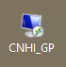

- Once logged in you will see an icon like this:
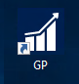 This is your Great Plains login and will be newly assigned to you.

If you have issues logging into Step 1 (RDP) email support at support@cnhi.com
If you have issues logging into Step 2 (GP) email Michelle Talerico @ mtalerico@cnhi.com

