Approving Great Plains Invoices
- Log into Great Plains.
- Click on the “Purchasing icon in the bottom left hand of the navigation panel.
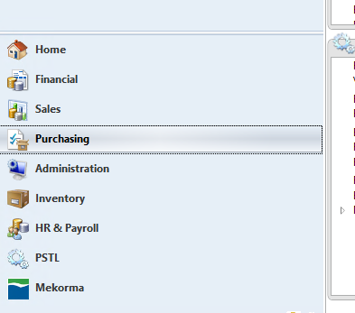
- Open the Payables Transactions dropdown in the upper left hand corner of the screen, then click on “Payables Transactions Pending”
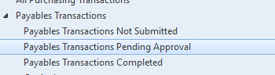
- You will see a list of invoices pending approval in the screen to the right. You can double click on it to view the details. When you double click you can view where it is being distributed by clicking on the “distributions” button. If you have double clicked on it you can approve or deny under the “workflow” icon at the top.
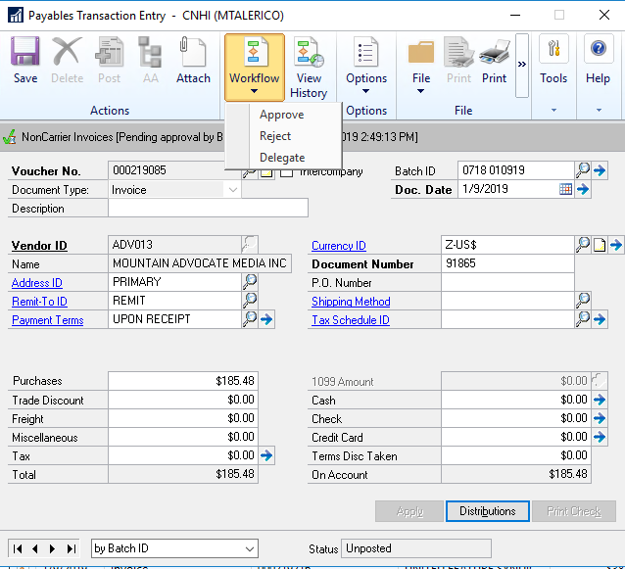

- If it is an invoice you already viewed or are used to paying you do not have to double click on the invoice. You can click on the box in the first window and click the “approve/complete” icon in the upper panel.

- 